**ABHISHEK SHARMA**

**500067644**

**R171218005**

**DevOps-B1**

LAB EXERCISE 6

**Aim: - Create a simple Maven Project using CLI.**

First, download Maven and follow the installation instructions. After that, type the following in a terminal or in a command prompt:

**1. mvn --version**

It should print out your installed version of Maven: -

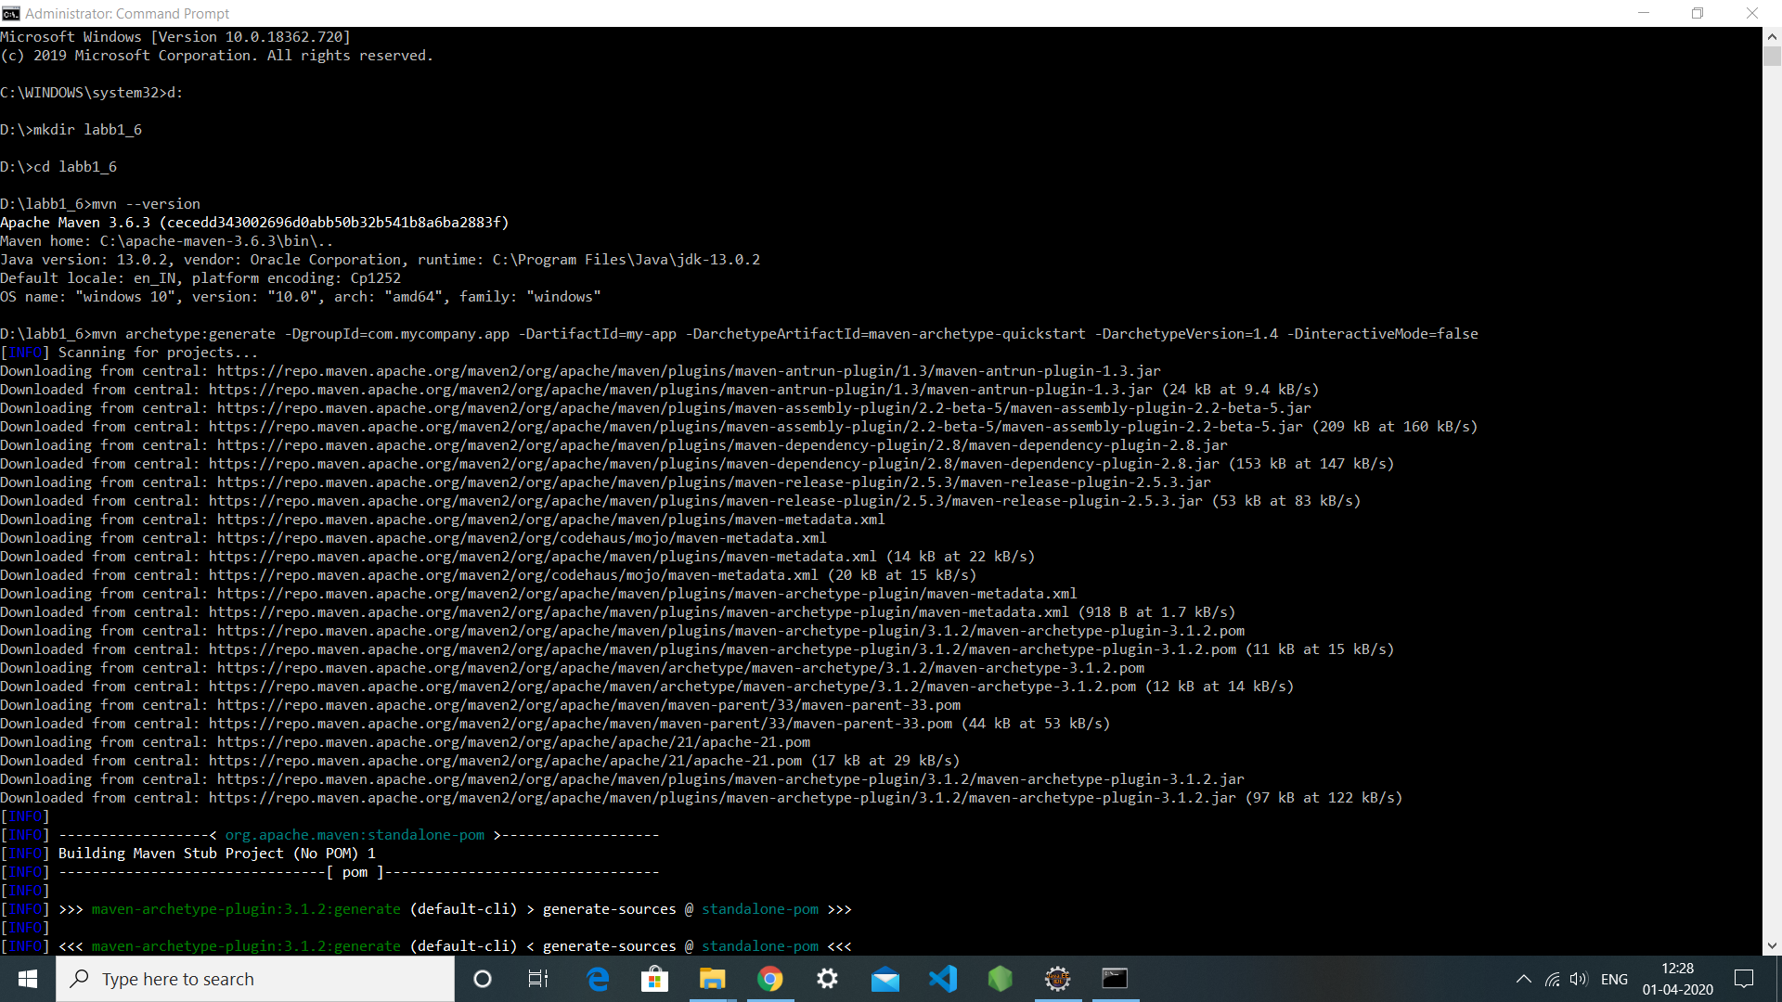

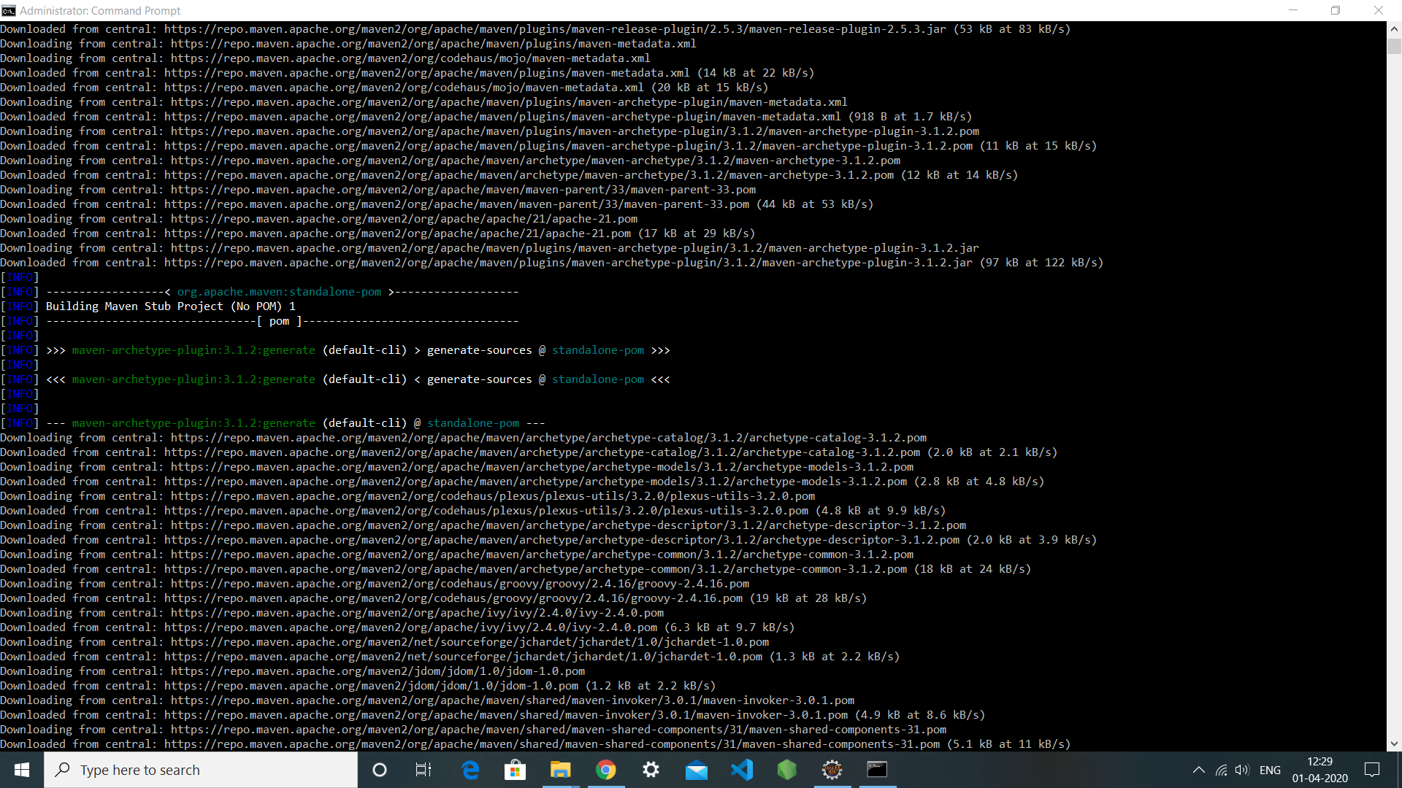

**Creating a Project**

**1. cd my-app**

Under this directory you will notice the following standard project structure.

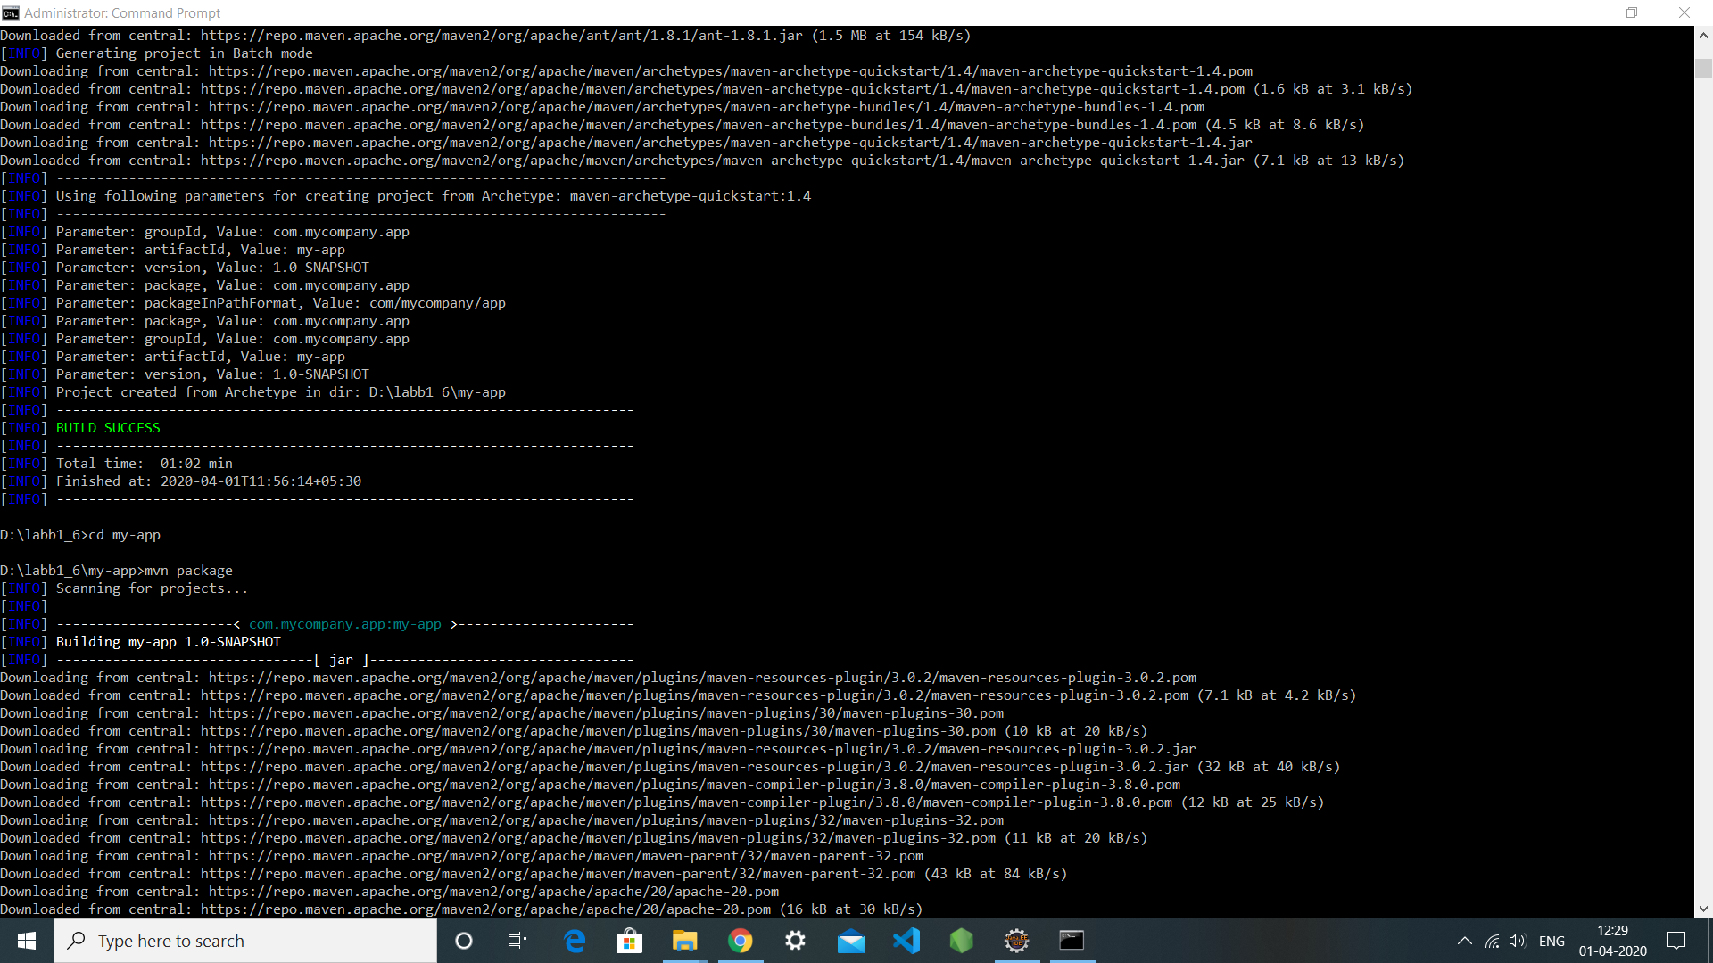

**The POM**

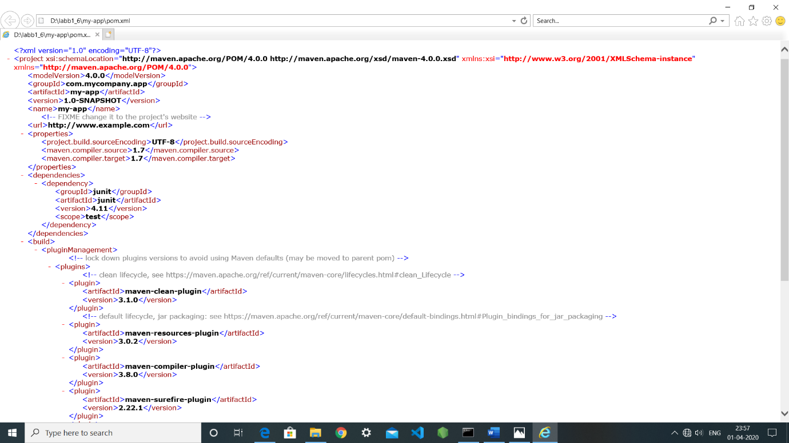

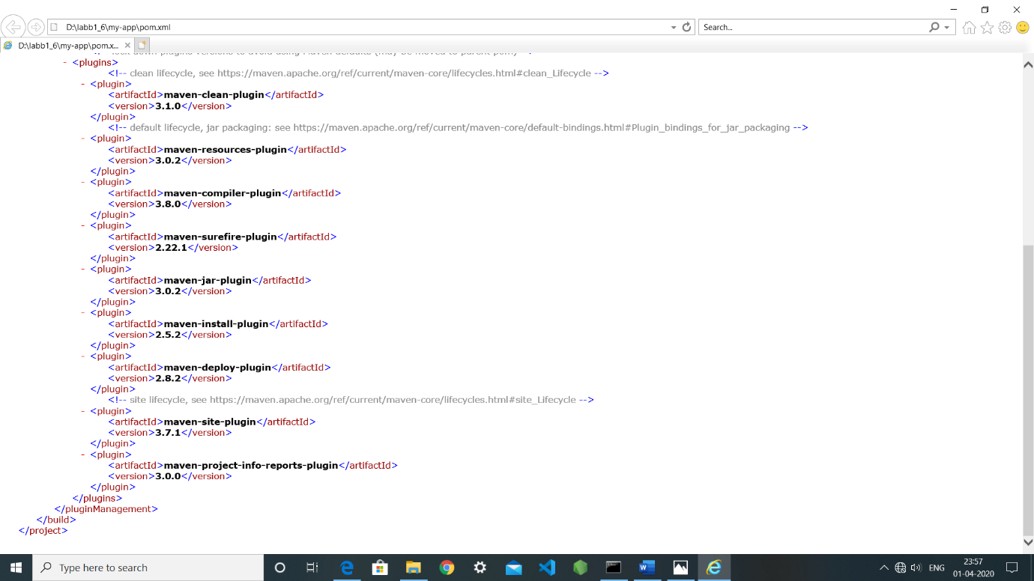

**Build the Project**

1. **mvn package**



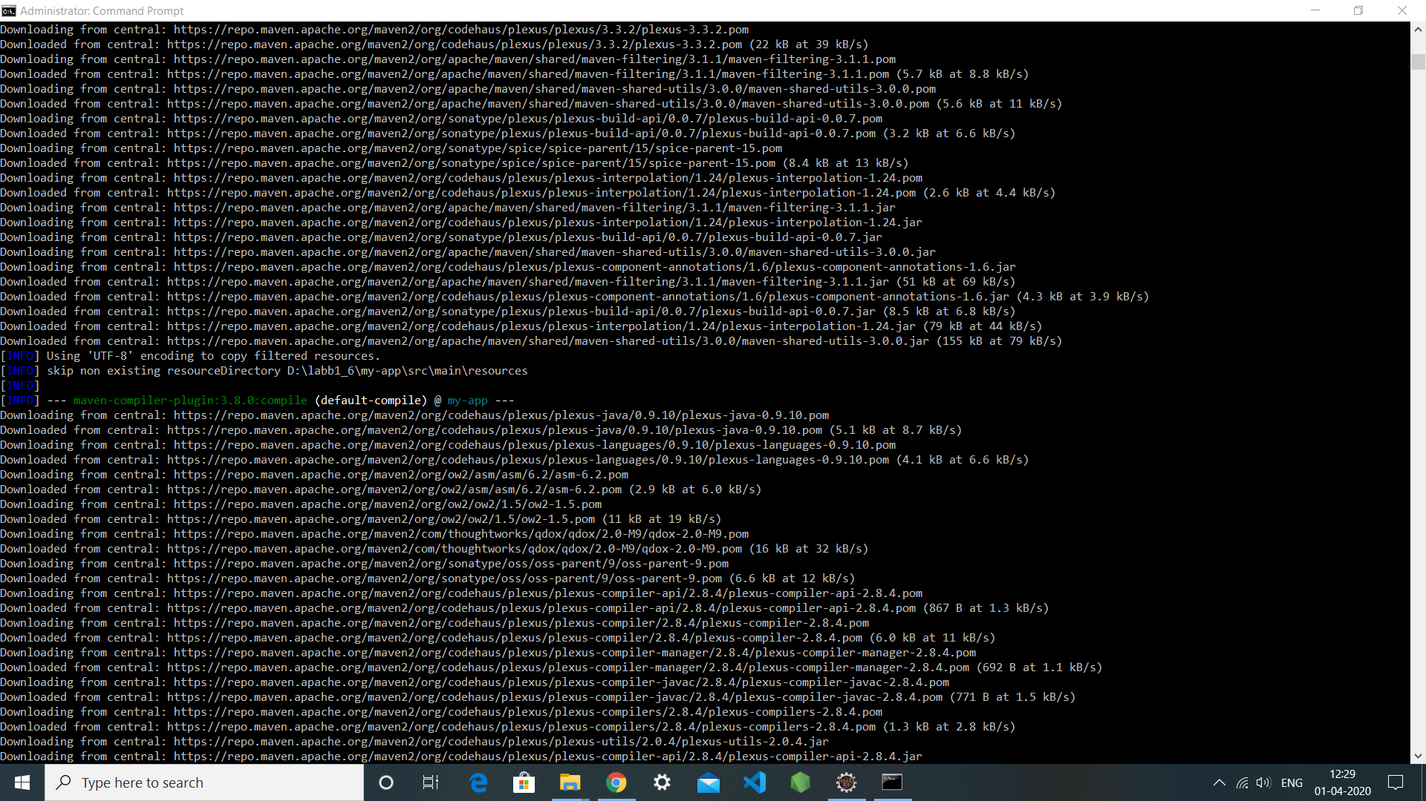

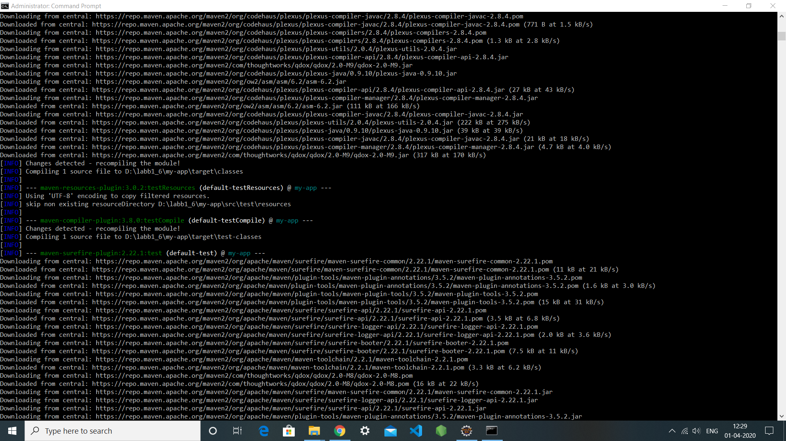

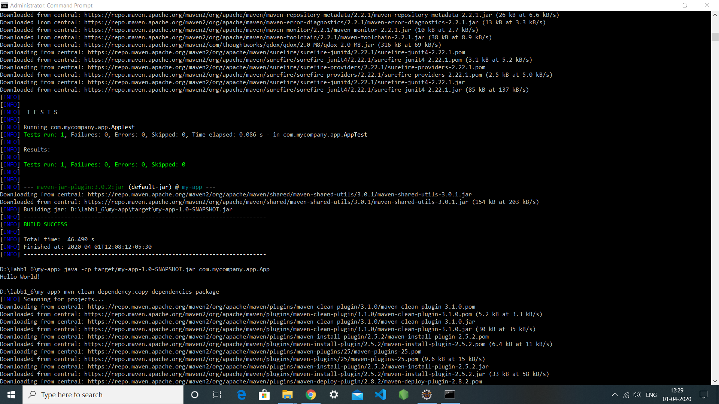

You may test the newly compiled and packaged JAR with the following command:

**1. java -cp target/my-app-1.0-SNAPSHOT.jar com.mycompany.app.App**

Which will print the quintessential:

1. **Hello World!**



1. **mvn clean dependency:copy-dependencies package**

This command will clean the project, copy dependencies, and package the project (executing all phases up to package, of course).



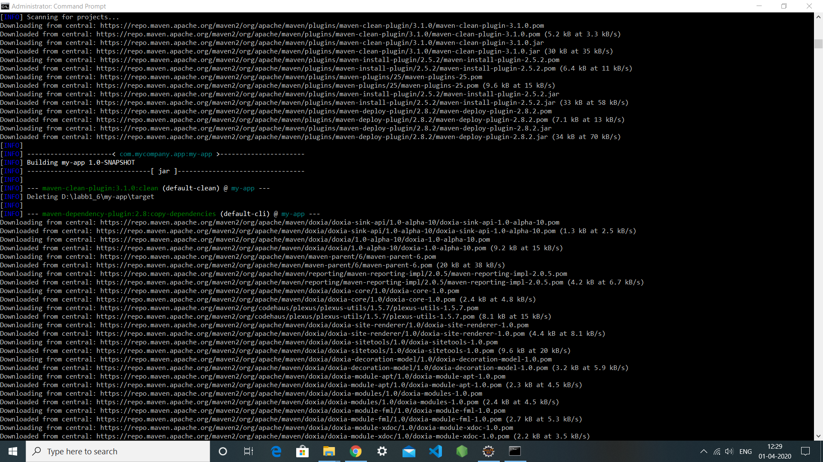

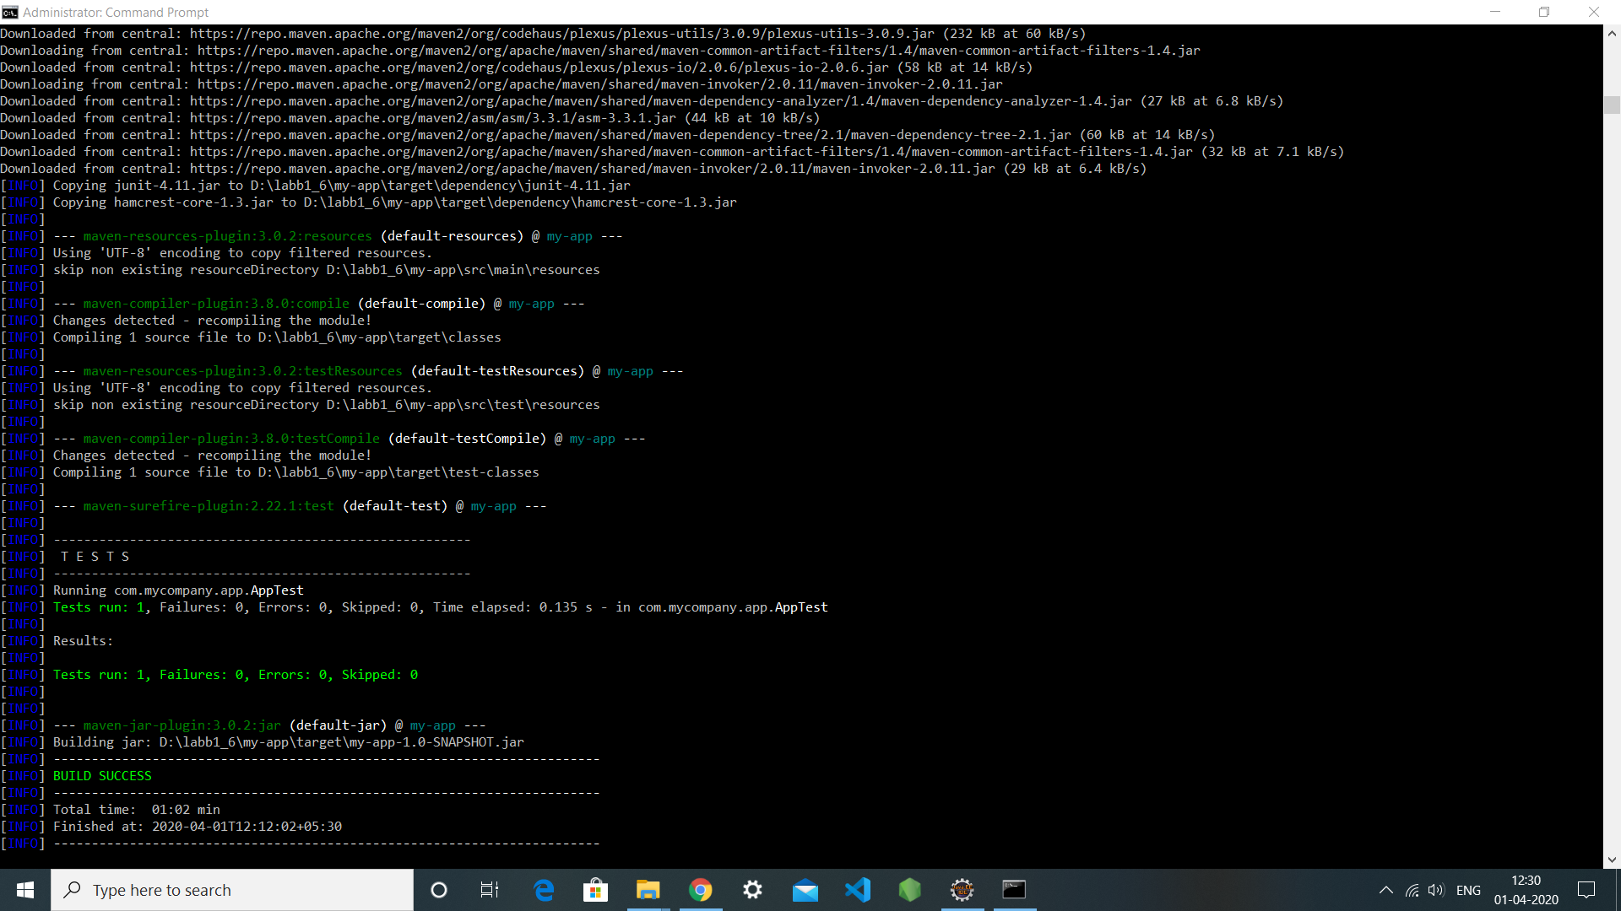

**Generating the Site**

**1. mvn site**

This phase generates a site based upon information on the project's pom. You can look at the documentation generated under target/site

